Nzinga Gamble
CS: 380
intelligence systems
DR. O Osuagwu
11/23/ 17
Yolo paper
Yolo ( an acronym for you only look once) actually looks at the image just once. object detection is considered to be one of the most challenging problems in the field of computer visions, in that it involves the combination of classification, and localization of objects within a scene. Although yolo2 can achieve real-time performance on a powerful GPU. Written in darknet, yolo is a custom deep learning framework, the weights are available, and downloadable only In darkner format.
R-cnn(convolutional neural networks) is know for its image classification it can now be used with excellent results in image instant segmentation both yolo, and r -cnn use large data for training the data rsecognition algotithm. Cnns have become a golden standard for classifying image It has improved, and, humans are now outperformed on the image net challenge. Object detection is one of the classical problems in computer vision. Detection is a more complex problem than classification which can also recognize objects, but does not give exact location or tell you where the object is located in the image-it would not work for images that contain more than one object.
Methology – Detailed description of how you set up the yolo environment and got images.
deep neutral networks(DNNs) have demonstrated to achieve superior object detection performance compared to other approaches, with yolo (an improved you only look once model)
being one of the state of the art in DNN-based object detection methods in terms of both speed and accuracy. In my attempt to download the yolo in the linux terminal, first I open the terminal to install all the tools thats needed to train the system to detect images in darknet, so i went into my cs380 file to execute these commands -

cd cs380
source activate OPENAI
cd darknet
git clone https://github.com/pjreddie/darknetcd
cd darknet
make
then install wget https://pjreddie.com/media files/yolo.weights
I run the detector – darknet detect cfg/yolo.cfg yolo.weights data/dog.jpg.
I also installed the label for each for the VOC. Darknet uses .txt files to store labels eg: <Object Class> <X> <Y> <Width>, <H>
after installing these tools I copy paste darknet, then I go back to my cs380 file and choose an image that I got from the internet (an eagle). I changed from the dog to the eagle, and run the detector.

Results – what did you see in each of these systems as you changed things?
I went back to my cs380 file and choose an image
To run yolo I copy and paste in my terminal in yolo environment.
./darknet detect cfg/yolo.cfg yolo.weights data/dog.jpg, dog was changed to bird.
The image is weighted and matched with the pre-trained yolo data file. I tested on more images in the same way. When I tested for a catRabbit the detector was unable to recognise, and box the two animals in the same image.

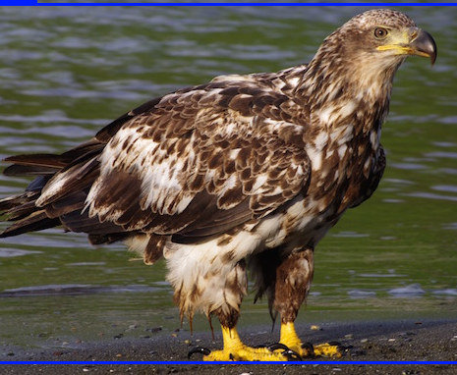

I tested on another image in the same way
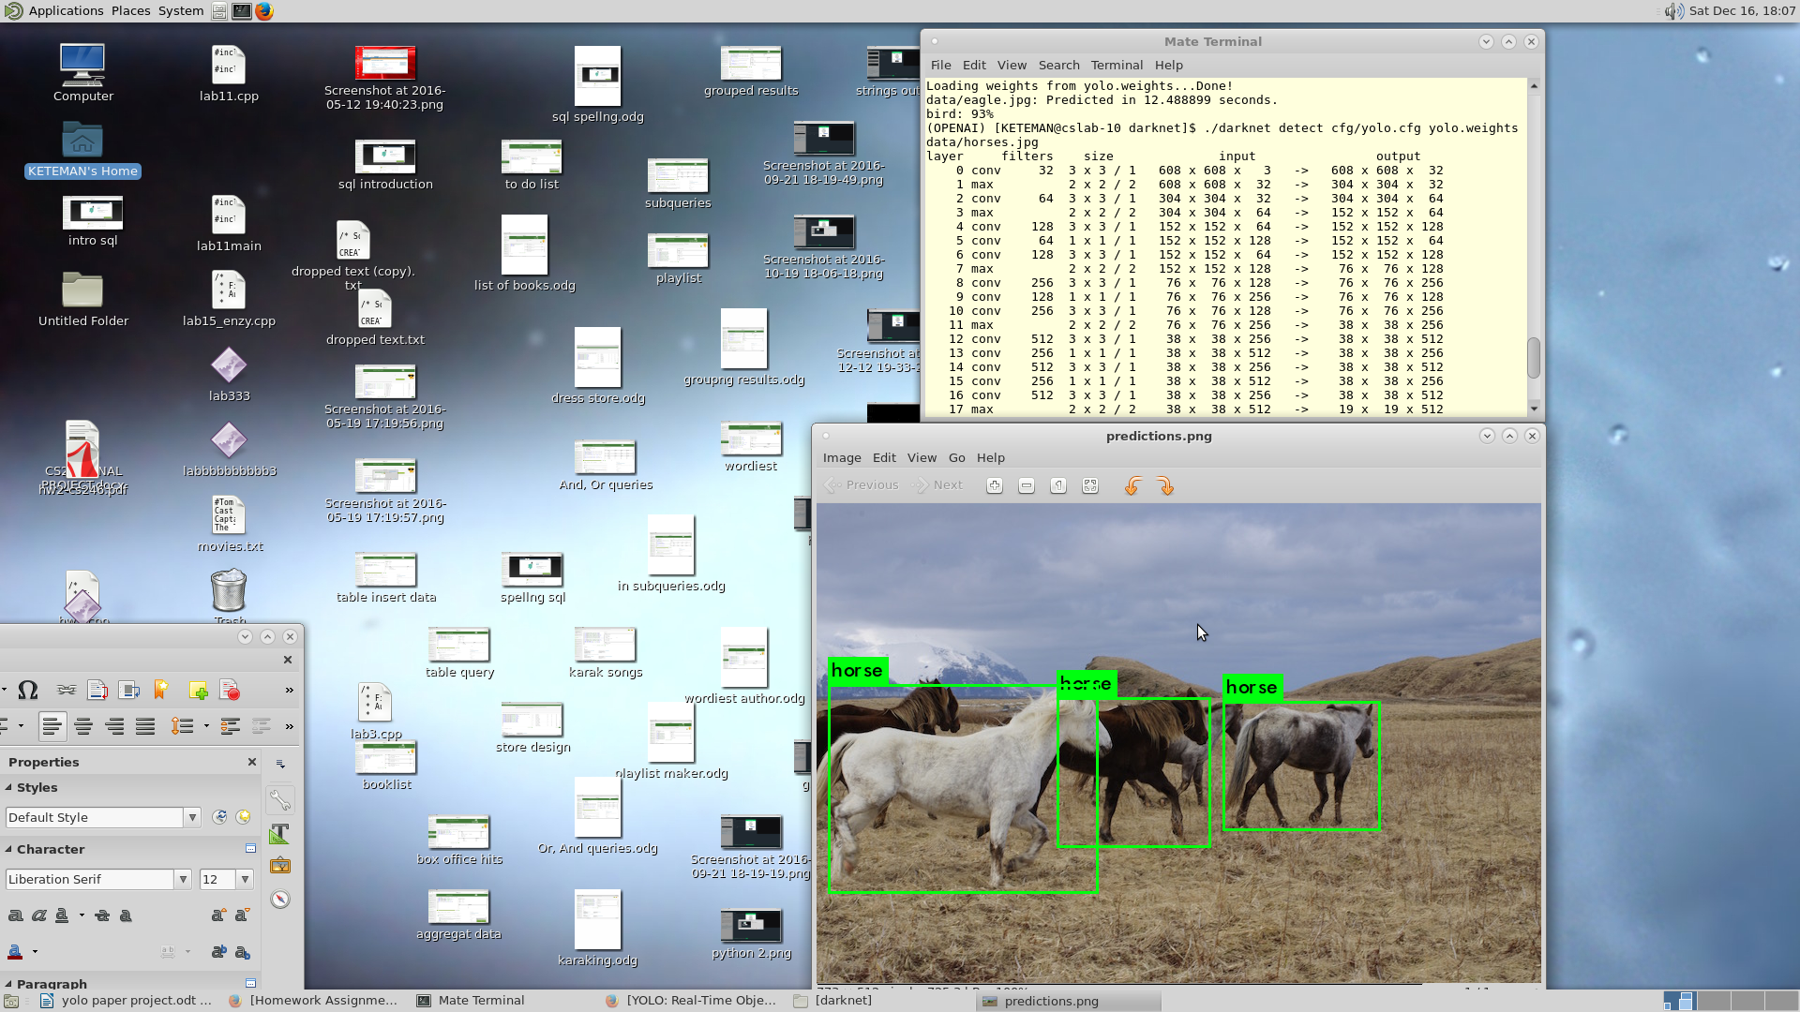

when I tested on another image I choose from the internet the results was not good. The detector was unable to box and label the two different animals in the same image. This is because the VOC was not trained to recognize the Rabbit and a Cat.

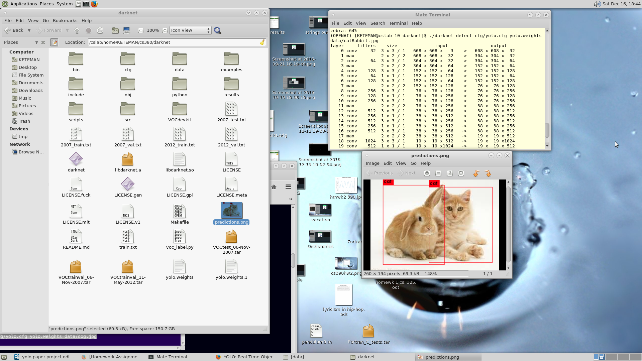

Conclusion – summary of your findings why are your findings interesting, important, what could it be ussed for, and is it good or bad….. it was interesting to see how the pretrained yolo did not recognized the image it was not trained to recognize. My task was to traine yolo2 to recognize images that I choose, but because of time I was unable to start that very important process as It takes days or weeks to install. It will surely improve the system. Using this system can be very interesting with a lot more training on a computer that is faster lika a GPU. “Fast yolo is the fastest general -purpose object detector it generalizes well to new domains making it ideal fo applications.” This application can be used by large companys, and also for shopping websites.

https://goo.l/bEs6Cj

